Shahan Nercessian (w/ William Matelski and Steven Kelm)
ES 95/MUS 53, Prof. Lehrman
Final Project
5/12/05

THE NINTENDARCADE

The Nintendarcade is an instrument that both toggle samples as well as acts as a melodic, note-triggering controller. Additions and even more deletions from the idea when it was originally conceived have been made, but in the end, the general layout of the controller is a customized arcade controller-inspired box similar to the one shown in Figure 1.
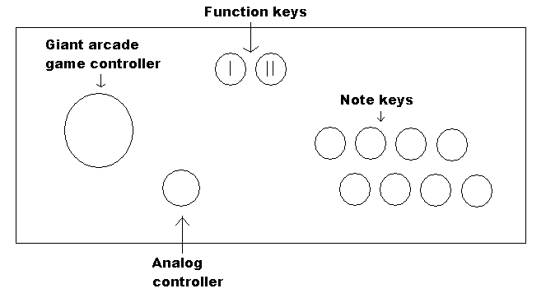

Figure 1 – The Nintendarcade (top-down)

The buttons/controllers on the Nintendarcade are connected to the leads of a Playstation One controller, which runs into a PSX to USB converter which goes straight into a computer. Incoming data is interpreted by the Joystick object in Max, and therefore, the use of a Doepfer box is conveniently avoided completely. The MIDI in used for the Nintendarcade is MIDINes, a Nintendo cartridge with a MIDI cable hanging out from it which has 5 MIDI channels: 2 square waves, a triangle wave, a noise channel, and a PCM channel. These are the 5 MIDI channels and sounds that were available for sequencing in the original 8-bit Nintendo, so the Nintendarcade, to a very high level, attempts to replicate this original vintage sound.

The Nintendarcade’s programming consists of two basic modules. One consists of logic pertaining to toggling MIDI samples and the other one consists of generating notes. Toggling between the two modules is done by the 2-player function button. The samples used were loaded into Ableton Live as a 5 channel x 8 sample matrix for a total of 40 samples to toggle. The giant arcade controller is actually digital, having 4 binary switches for each cardinal direction for a total of 8 combinations (two switches on forming a diagonal). A combination of a joypad direction (channel #) and pressing one of the 8 note buttons (sample on channel) results in toggling a channel. Since there are only 5 MIDI channels on the MIDINes, only 5 of the directions of the giant joystick are used. Namely, E toggles the square wave 1 channel (melody), SE the square wave 2 (counter-melody), S the triangle wave (bass), SW the noise (percussion #1), W the PCM (percussion #2). The samples that are used either samples of famous Nintendo game music or original grooves that were sequenced into Live. In addition, the analog controller sends controller value for “random pitch” to each of the 5 channels as an added element of mayhem.

The second module, known as improv mode, involves generating notes to construct melodies. Since we did not have 12 note buttons and the box that was used to hold the instrument had already been made, the 8 note keys correspond to a note in the C major scale, doubling the C on top. The 1-player function key changes the octave, going up 3 octaves and cycling back down to the lowest octave. In order to allow for chromaticism, holding down the big joystick (S direction) increases the pitch of whatever button to be pressed by a semitone. As a design preference, the note will not sound half a step higher if the note is played and the joypad is held down afterwards.

The Max programming involved with implementing the Nintendarcade is quite involved. A lot of this programming had to do with working with USB rather than the Doepfer box. The Joystick object had to be used to route the 2-player function key. This function key toggled either the sample (or mixer) patch or the melody (improv/player) patch, and every button was routed accordingly using the Joystick object. From there, tedious algorithms had to be used to make the buttons function properly. At first, holding down a button resulted in triggering either a note or a sample multiple times. A mix of toggles, bangs, and the Onebang Max object were used in order to make holding a button result in a single note/sample toggle. A similar amalgamation of Max objects, bangs, and toggles were used simply for a toggle to act as a toggle because something in the way data was being processed was not allowing the toggle object to work properly.

From there, the coding was a lot more straightforward. The mixer patch consisted of a few math operations. A certain giant joystick direction sent out a specific multiple of ten, while a specific note key sent out a specific digit. The sum of the two numbers was the controller number for a certain sample. This controller number was sent into a Ctlout. There is a Ctlout associated with every note key, allowing multiple samples to be triggered at the same time. In the player patch, the note number to be sent out into a Noteout was equal to (specific base note of a note key) + (12*octave #) + (raise half step from joystick). When the button was released, it triggered a bang which sent out a flush to generate a note-off. Each note key had their own Noteout to allow for polyphony.

The Nintendarcade is an interesting controller that allows for both conventional and non-conventional musical expression. My own involvement in the project was having a huge responsibility in making working Max code as well as making and gathering good sequences for Live. Will had his hand in everything, contributing to construction, Max coding, and educating the group about how to use Live. Steve added much to construction, sequencing, and offering alternatives in Max when troubleshooting.

