EMID Fall 2019

The “IMU”sic Maker
Kristen Schretter, Max Luo, and Gus Meyer

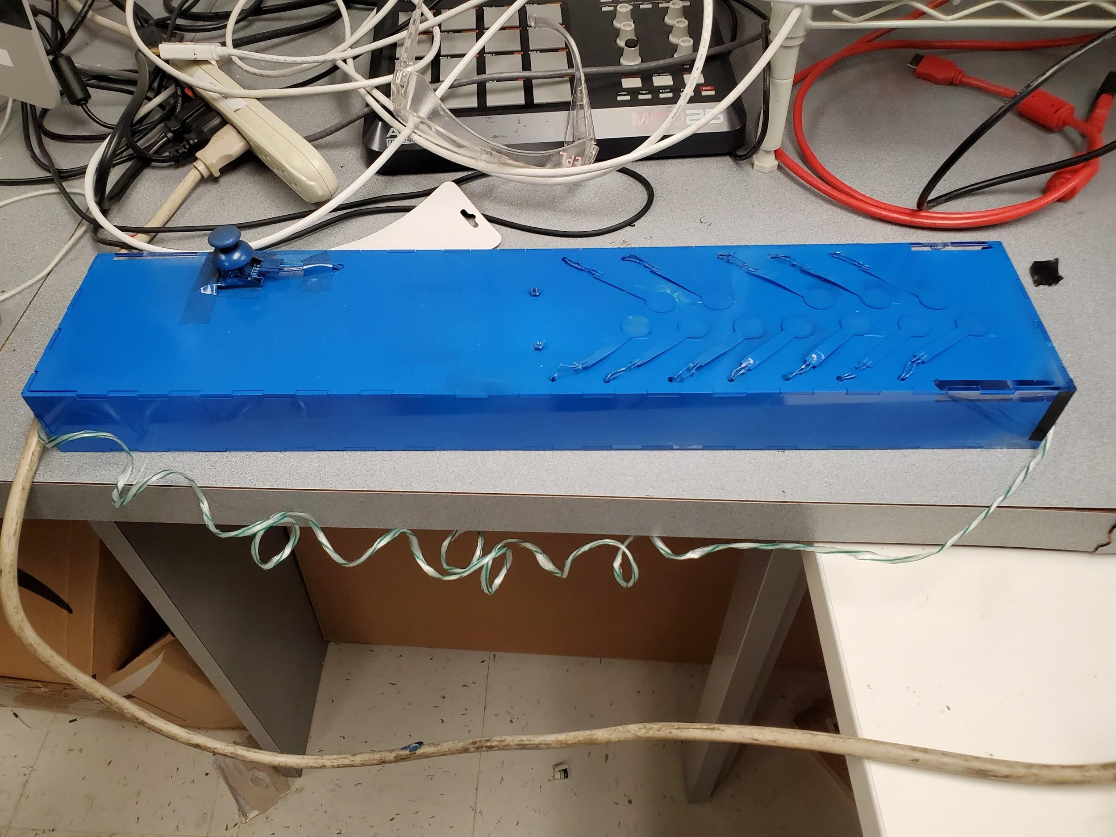

Introduction
The IMUsic Maker is an electronic instrument that changes its timbre based on its orientation. There are keys for the right hand to play as well as a joystick to modify the sound. By taking advantage of three orientations, the user can mix and match three different instrument samples.

The default setting maps to piano if flat in the XY plane, guitar if flat in the YZ plane, and saxophone if flat in the XZ plane. When tilted from its “home” plane, the volume of each instrument decreases until it is 0 in the other instruments’ planes.

Design

Sleek and simple, the IMUsic Maker has the form of a thin box to streamline usability. The instrument’s dimensions are 23” by 5” by 2”, large enough to easily hold the interior electronics and be played by both hands but also small enough for the user to reach the keys and switch easily. The paint color gives it personality, and the bottom, allowing the user to see the electronics on the inside, is reminiscent of the open design of the rhythmicon. The sides feature laser-cut grooves on the edges to fit together more nicely than straight cuts, and this design also allows for a removable top, making it easier to modify and replace components.

The note keys are in a piano format to decrease the learning curve of a new player. The direction of the FSRs were decided to minimize interference and issues due to overlap, and follow nice geometric lines to please the eye. On the left hand side is the joystick.
A strap is also included to make playing the instrument in “guitar” and “saxophone” modes easier.

Parts list

6 sheets of clear acrylic, laser cut (two 23” x 5”, two 5” x 2”, two 23” x 2”)
Arduino Mega
2 IMU Digital Combo Board 6DOF
Wires
12 FSRs
PSP1000 Joystick
3-Dimensional Accelerometer

Redesign process
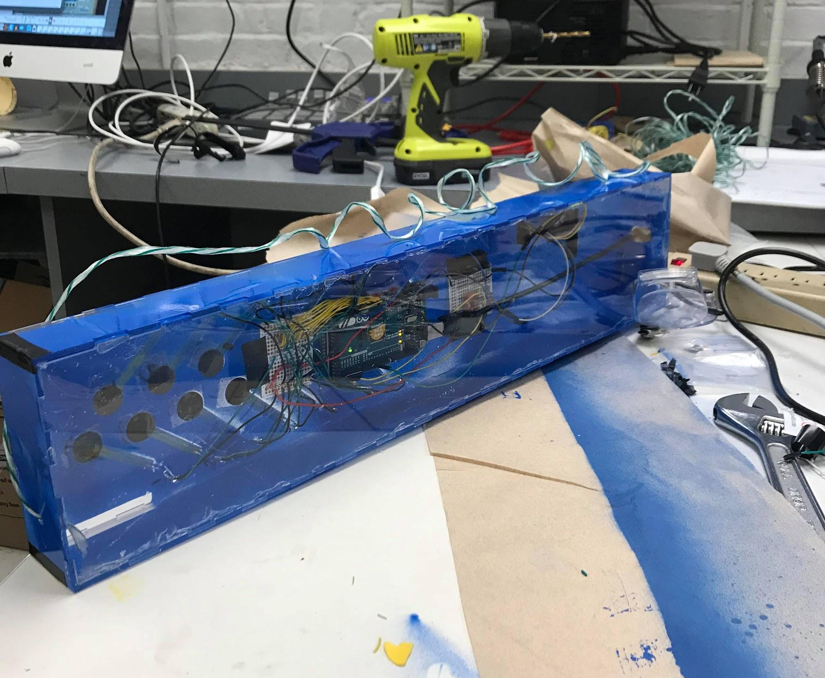

Hardware
The largest electronics addition to the second version of the IMUsic Maker was the joystick. Connecting the joystick allowed for more control on the notes played. The x axis controls the pitch bend, and the y axis controls the mod wheel, allowing the user to modify the parameters chosen in Reason. Automatically, it is set to control LFO.

The second version of the project also includes more robust wiring that holds together better and has clear organization and wires that complement the color of the FSRs better. The arduino was bolted into the mainframe, which is now made of laser-cut clear acrylic instead of wood and is in the shape of a box instead of a board with a recess cut in so the electronics are enclosed. The last change was the reordering of the FSRs. In the first design, they were in three rows of four since the user has 4 free fingers, but this caused the FSRs to have to bend too much to go through the board to the Aruduino. In the final design, the FSRs lie completely flat to avoid any interference from bending, and the spacing in this line design was not feasible, so we went back to a basic keyboard layout.

Pins in Arduino:
Analog 0 | FSR 1
Analog 1 | FSR 2
Analog 2 | FSR 3
Analog 3 | FSR 4
Analog 4 | FSR 5
Analog 5 | FSR 6
Analog 6 | FSR 7
Analog 7 | FSR 8
Analog 8 | FSR 9
Analog 9 | FSR 10
Analog 10 | FSR 11
Analog 11 | FSR 12
Analog 12 | Joystick position
Analog 13 | Joystick position
COM20 (labeled a14 in Max) | Accelerometer axis
COM21 (labeled a15 in Max) | Accelerometer axis
Digital 2 | Joystick Switch
Ground | Joystick Grd Port
3.3 Volts | FSR IMU Board
5 Volts | Joystick 5V Port
Ground | Accelerometer IMU Board

Max & Reason
In terms of software, the Max patch was expanded in a number of ways. The original math for the accelerometer caused the instrument to play loudest when in a “pure” instrument state and lower whenever they are mixed. By making the math parabolic and not linear, a near constant volume was achieved. The objects to connect the joystick axes to the mod and pitch bend wheels was also added. Lastly, because the range of the instrument is small, a sequencer that can be initiated with a press of the switch involving pitches below and above the octave the instrument is in was added to give a deeper background for the user to play on top of. This part of the patch is based on the sequencer example from the EMID file, but includes two sequencers, one above the range the instrument and one below, and for listener interest, these are set at different tempos. The upper register has a 3 octave range while the lower register has a 2 octave range.

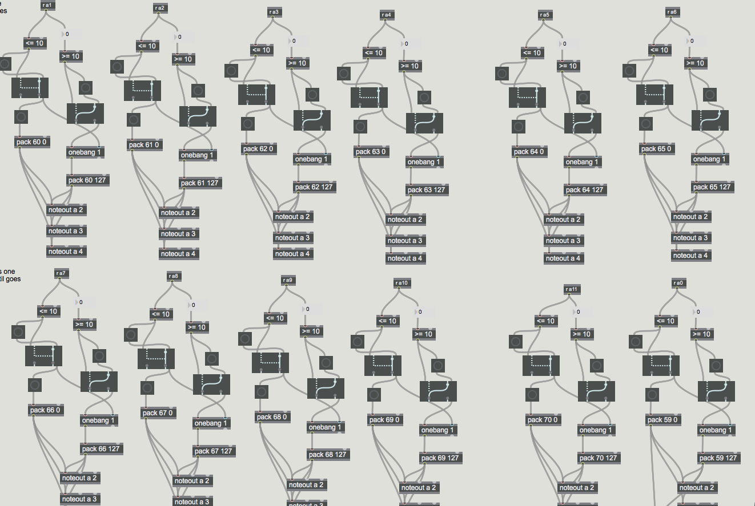
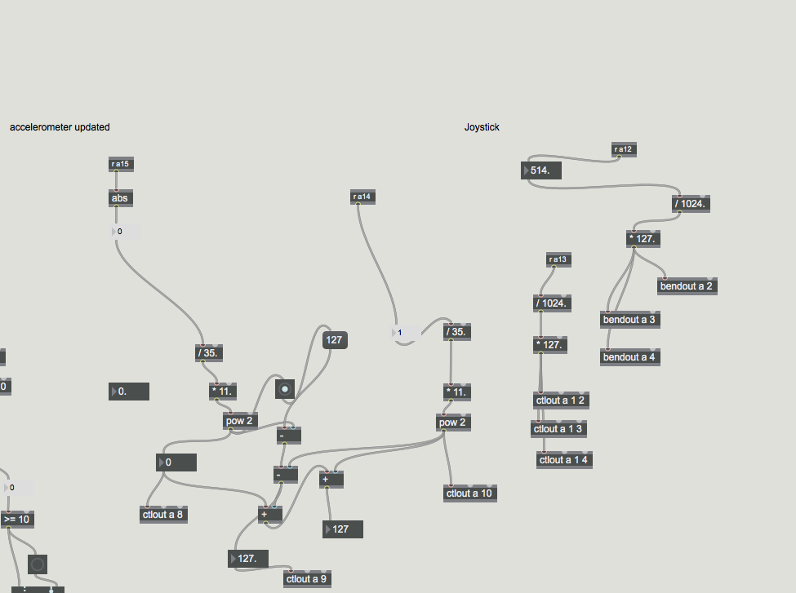
Final Max Patch:
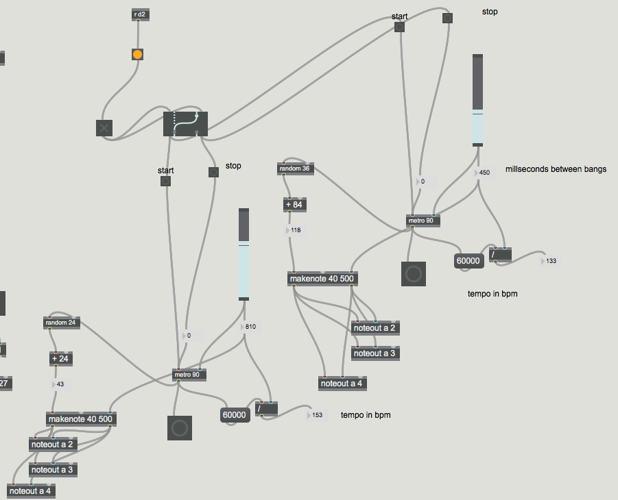

In the reason patch, the Clavinet sound was changed to a Saxophone sound and the LFO was turned on and linked to the Mod Wheel.
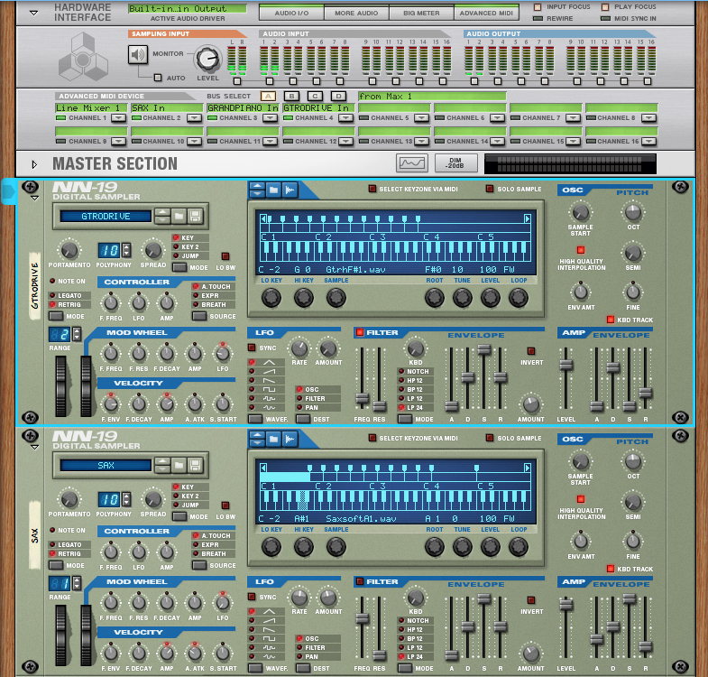
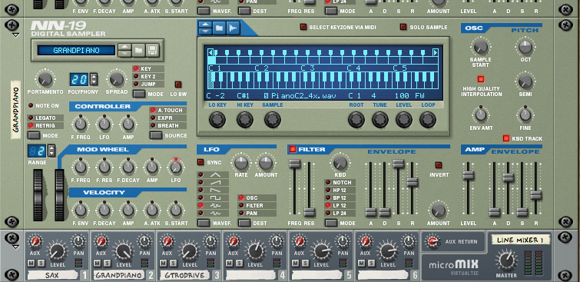

The Future of the IMUsic Maker
The first improvement that would be made going forward would be to change the math in the Max patch even more to get the transitions between instruments to be more even in terms of volume. Next, because the range of the instrument is limited, octave keys could be added. These would have to be buttons as all the analog pin numbers are taken up by other FSRs. In terms of visual design, the FSRs can have a different color than the rest of the board instead of being the same color as the rest in order to make it pop. It also might be interesting to have different sequencers, and pushing the button on the joystick could trigger one of them at random, giving more variation to the instrument than having one that plays each time.

